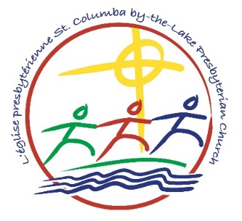
Summer Worship 2020

Life in the Spirit

Prelude

Welcome

Call to Worship
We gather to worship God.
We come seeking comfort, inspiration,
community, and insight.
We come to open ourselves
to the power of God’s presence in our midst.
We come to offer up the seasons
and the turnings in our lives,
and to ask God’s help
in our learning and in our growing.
God has given us this beautiful earth,
all that grows, all that lives upon it.
God has given us breath to live and spirit to love.
Thanks be to God.
God has gathered us into a community of care and worship.
Let us worship God
with love, thanksgiving, and praise.

Hymn

Prayer of Adoration and Confession

Response to Prayer - 27
As the deer pants for the water
so my soul longs after you;
you alone are my heart’s desire,
and I long to worship you.
You alone are my strength and shield;
to you alone may my spirit yield.
You alone are my heart’s desire,
and I long to worship you.

Pardon
The peace of Christ be with you always.
And also with you.

Scripture Readings
This is the word of the Lord.
Thanks be to God.

Hymn / Musical Interlude

Sermon Life in the Spirit

Hymn / Musical Interlude

Prayer of the People
We pray to the Lord.
Lord, hear our prayer.

Our Father in heaven
Hallowed be your name,
Your kingdom come,
Your will be done,
on earth as in heaven.
Give us today our daily bread.
Forgive us our sins
as we forgive those
who sin against us.
Save us from the time of trial
and deliver us from evil.
For the kingdom, the power
and the glory are yours,
now and forever.
Amen.

Hymn

Benediction

Postlude

St. Columba’s Welcome Statement
We are called to love, respect and value God's world
and all the people who inhabit it.
Our community is strengthened and enriched
by the full inclusion of people of all ages, races, abilities,
sexual orientations, gender identities, spiritual perspectives,
and socioeconomic backgrounds.
Everyone is invited to travel with us
as we each explore our journeys of faith,
whether the path is clear or winding, easy or exhausting,
or sometimes just feels like it is going round in circles.
Together, we work to make our community one
where God's love is truly known.

